1. Create a virtual machine with two operating systems, Windows 7 and Windows 10: We already have the VM with the two OS from last exercise:
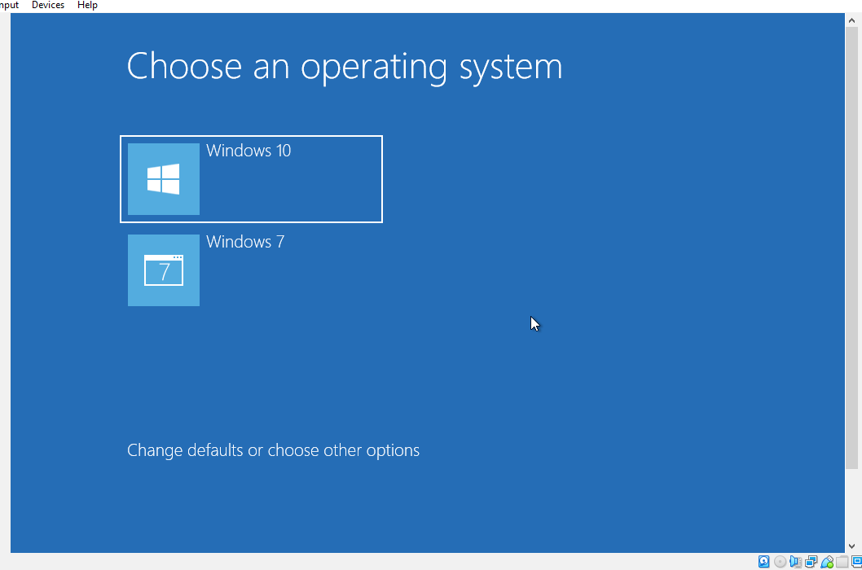

:

Choose Windows 7 as the default operating system, which will boot
after 5 seconds unless Windows 10 is manually selected:
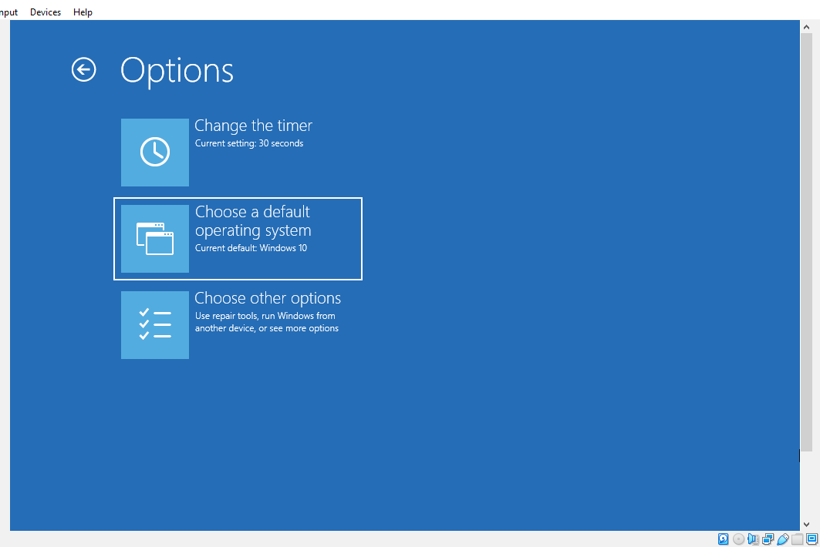
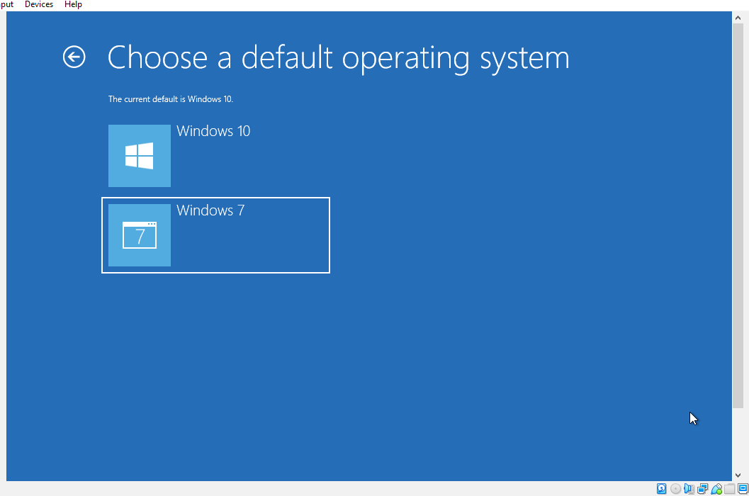

And change the timer to 5 second, you will choose the option Change the timer:
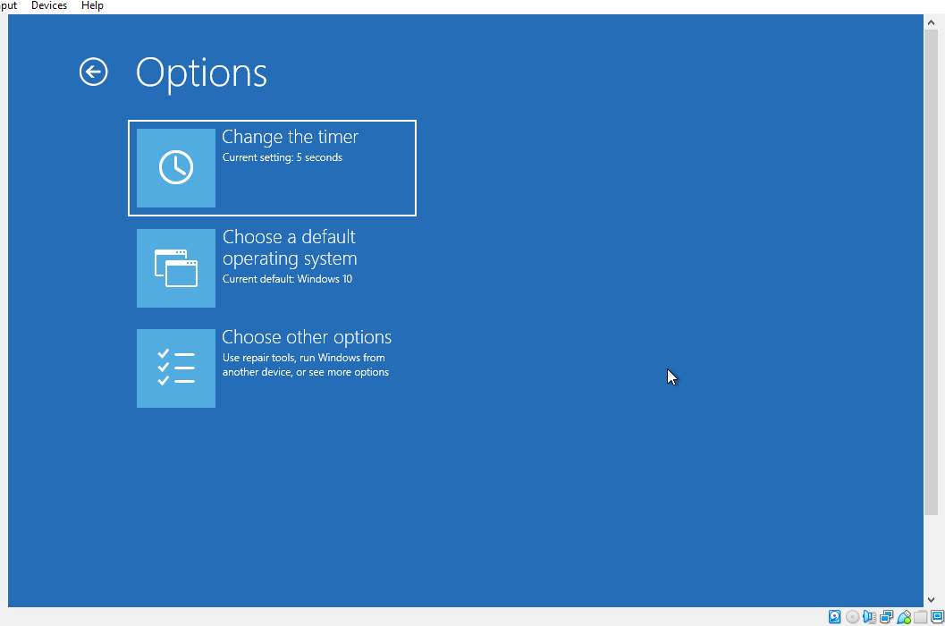

And your screen will see like this:
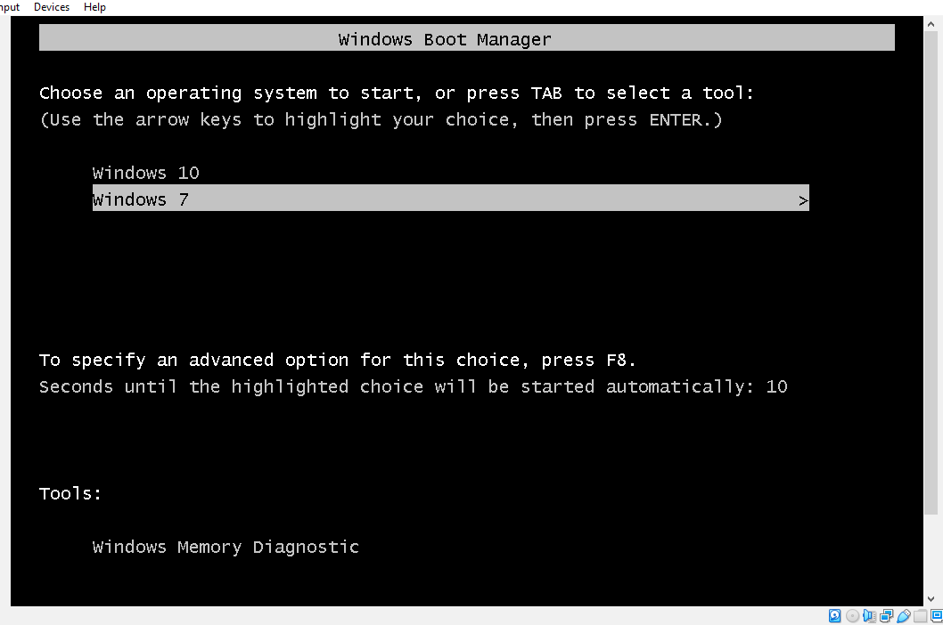
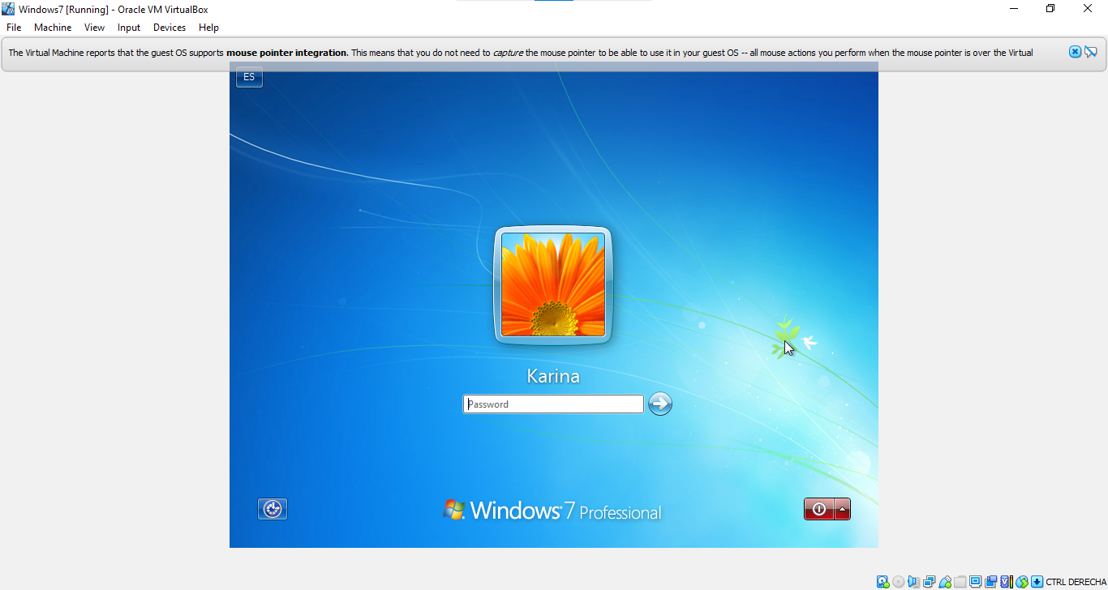

Another way to do it is front the option System Configuration from the Windows searcher:
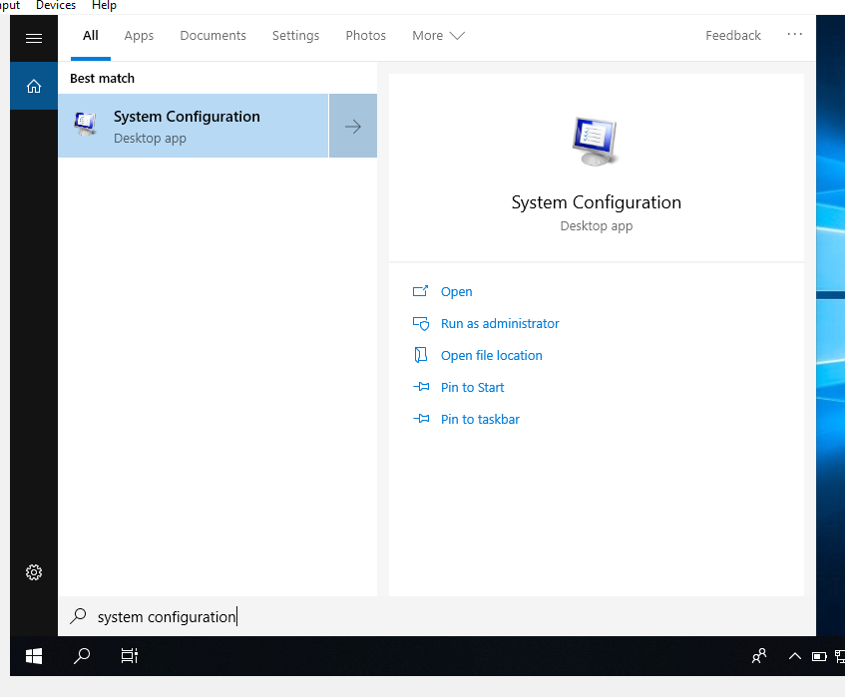

Then select the Boot option, where you could choose which OS set as default and the Timeout to start the OS:
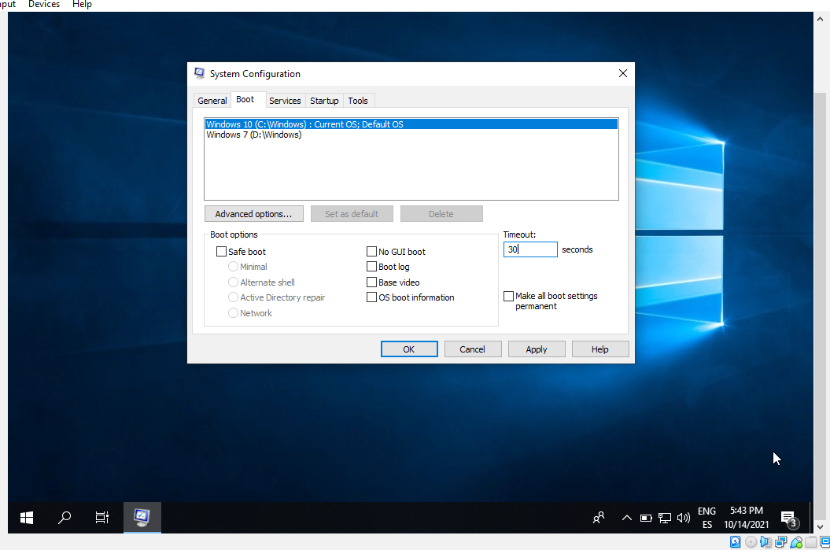

2. Create a virtual machine with two operating systems, Windows 7 (or Windows 10):
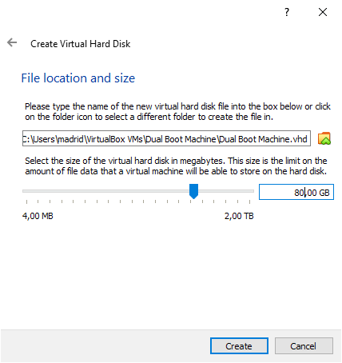
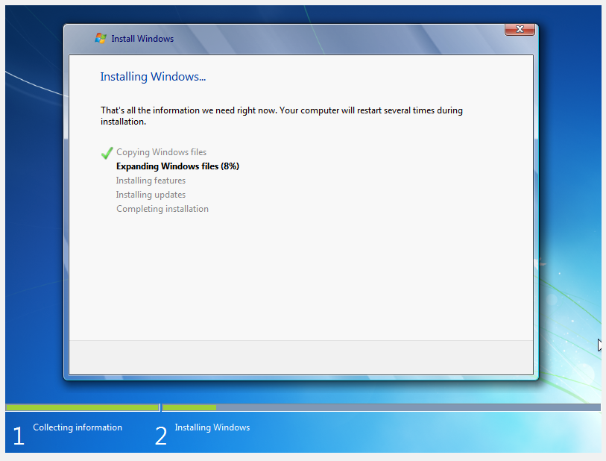

and Ubuntu 20.04 (in this order) and configure the bootloader to:
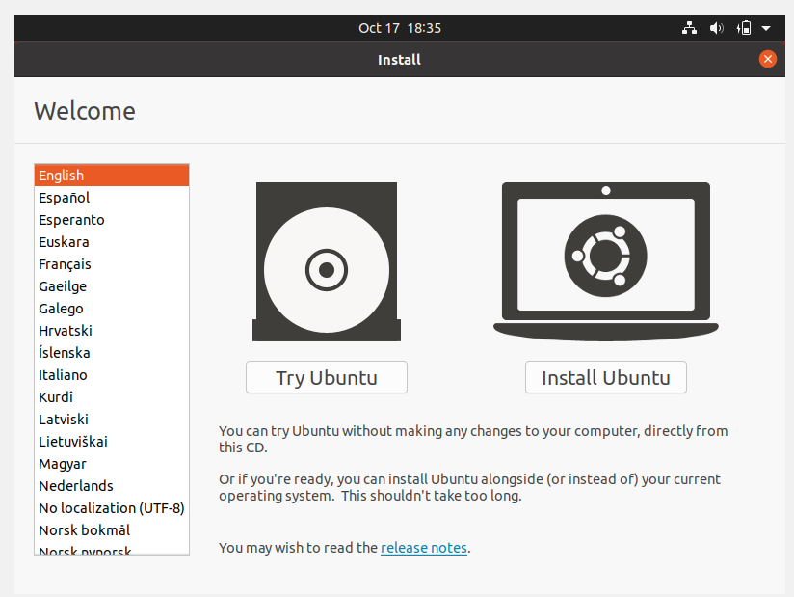
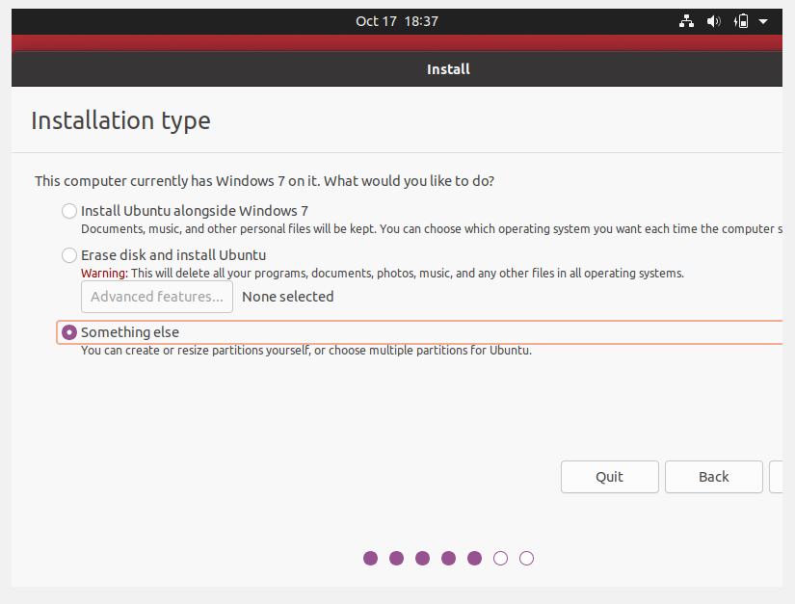

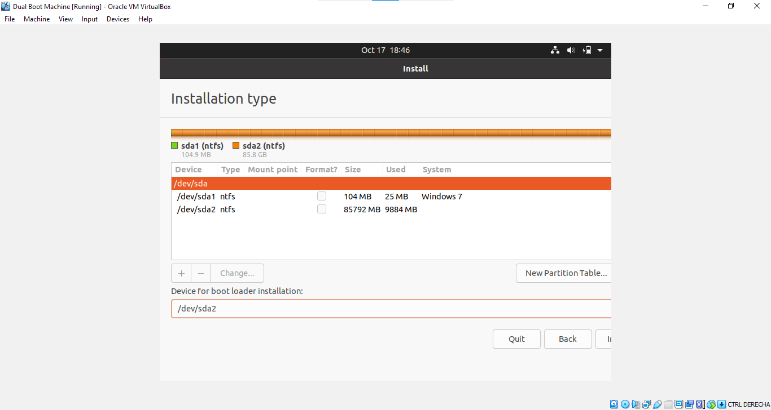
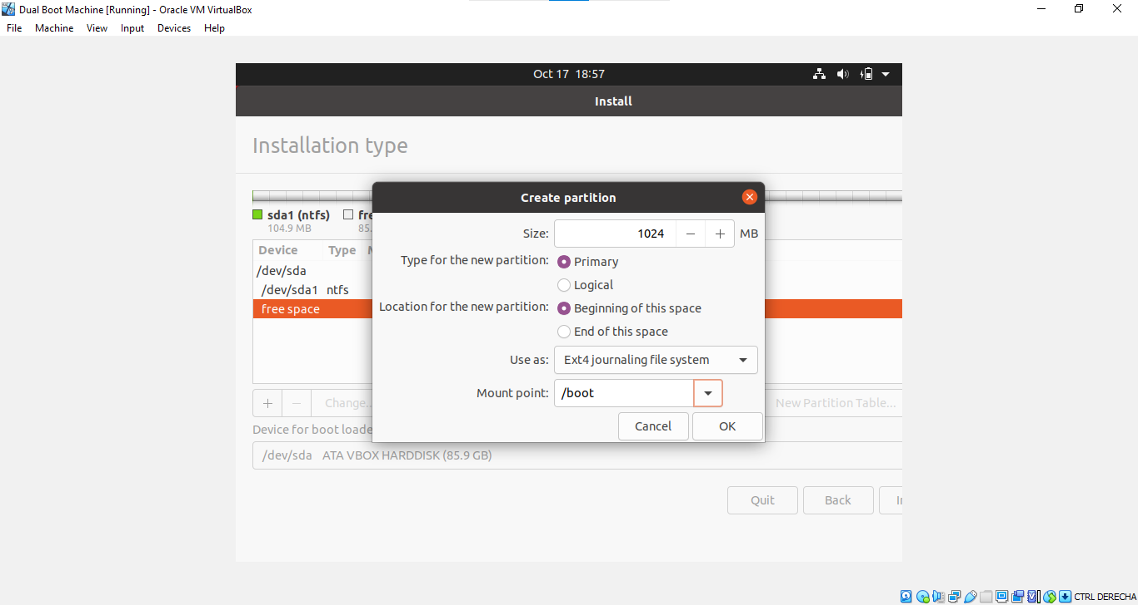

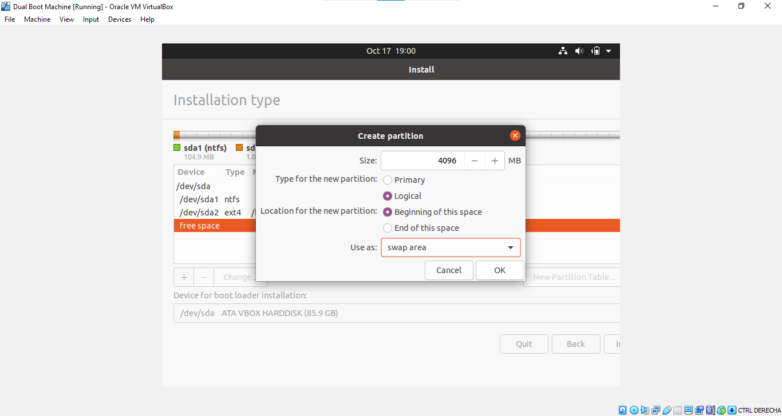
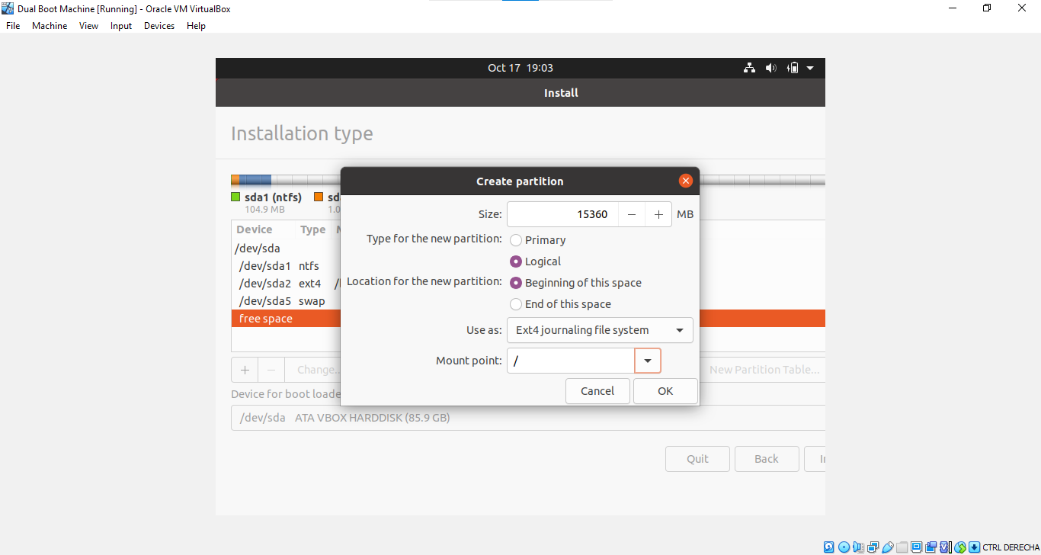

I could not finish to install the two OS, something got wrong, I will try it again the next day, but I finished exercise 1

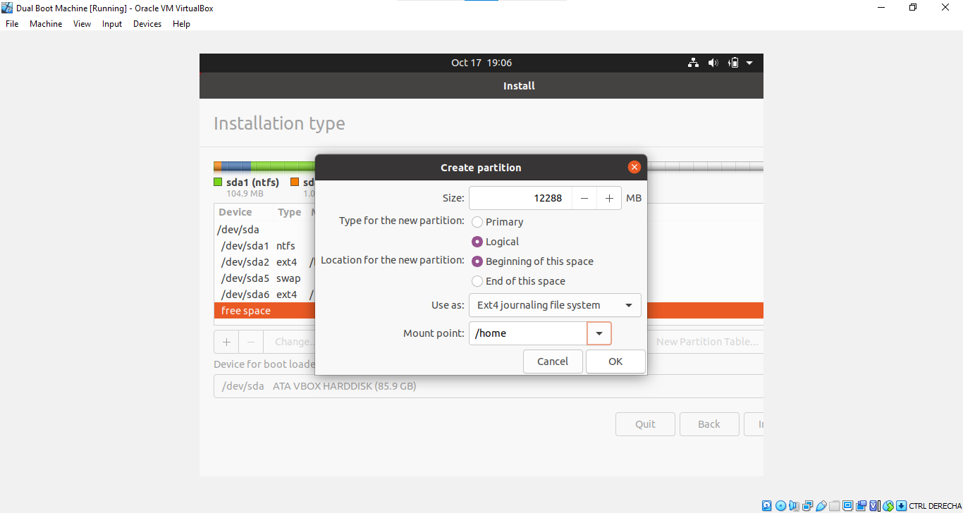
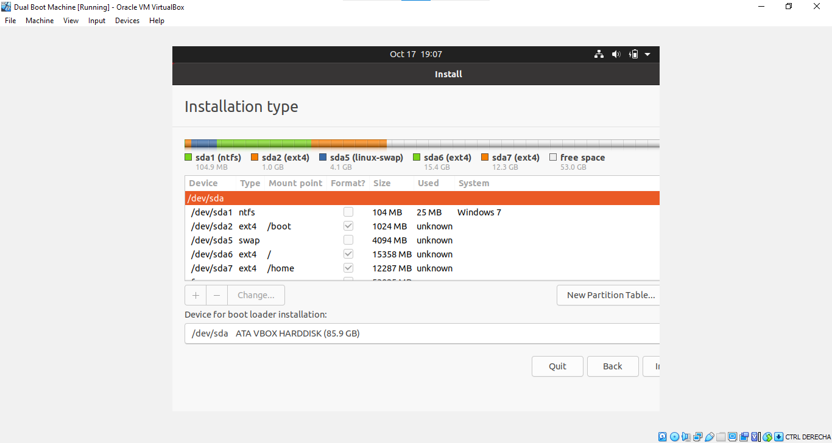

a. Set Windows as default entry and boot after 15 seconds if the user does not
select another option in the menu.
b. Boot Ubuntu without displaying the menu after showing a 10 seconds
countdown.
c. Boot Ubuntu without displaying the menu.
d. Boot Windows without displaying the menu.

